Current Events Article Report

You will complete a current events report that will be due every Monday.
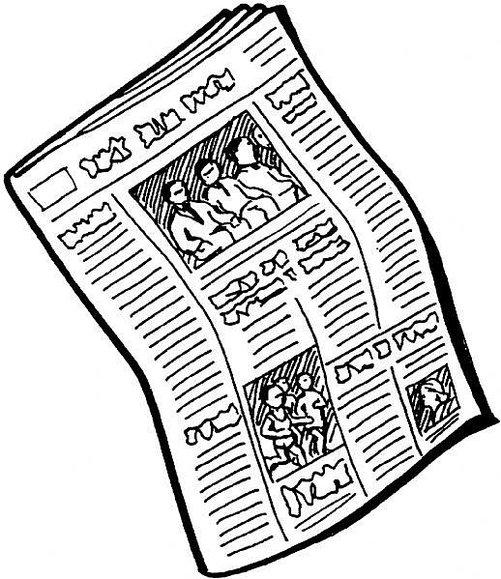
1. Choose an article from the provided Scholastic News magazine that appeals to you. Article should be at least 4 paragraphs long and have enough "meat" to it that you can summarize the article and add your own opinion to it.

2. Read the article to make sure you understand what it is talking about. Take time to talk about the article with someone at home as this is a good way to make sure you are clear as to what the article is all about.

3. Summary: Write a paragraph (6-7 sentences) summarizing the article. Be sure you have factual information included in your summary.

4. Opinion: Write a paragraph (6-7 sentences) with your opinion on the article. What did you think about the article? If the article made you feel a certain way, share your thoughts.

Some ideas to consider, depending on the type of article you choose:
- Do you agree / disagree with what is being said?
- Did you learn something new?
- Are you more informed about what is going on in your area, the nation, the world?
- Has the article inspired you?
- Does the article leave you wanting to "take action" and do something?

Guiding questions

Summary:
1) What is the article? (Name of article.. where did you find it from?)
2) What happened in the story/article? What was the main current event?
3) Who is the article written about? Who does the event affect?
4) When did this event happen/occur?
5) Where does the article take place? (a city? a school? the US? another country?)
6) Why is this current events important to the community/country/world?
7) Why did the event happen (what caused it?)
8) What are the important key details in the article that sticks out to a reader.

Opinion:
1) Why did you choose this article out of all the others?
2) Did you like the article?
3) How/why do you think this article was written? (to give information? to persuade a reader?)
4) Is this current event important to you? Why or why not?
5) What questions/comments do you have for the author of the article?
6) What questions/comments do you have for the people who may have been described in the article?
7) Would you recommend this article to a friend or family member? Why or why not?

